Erie County Technical School
Lisa Sorensen, Admission Coordinator
September 2018 - Board Report

The school year began celebrating the First 8 Days with fun activities designed to assist the new students in making a positive transition to ECTS and to allow returning students to build new relationships. We ate popsicles, played Minute to Win It games, shot off rockets, and had a Spirit Day picnic. It was so nice to see students from all 11 sending districts having fun together. The photos below are examples of these 8 great days.

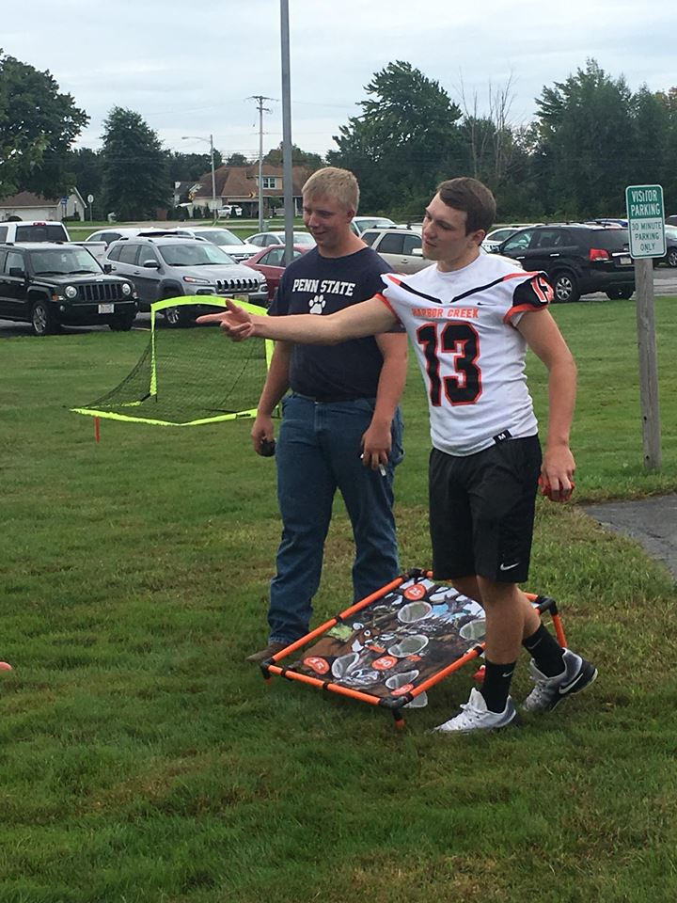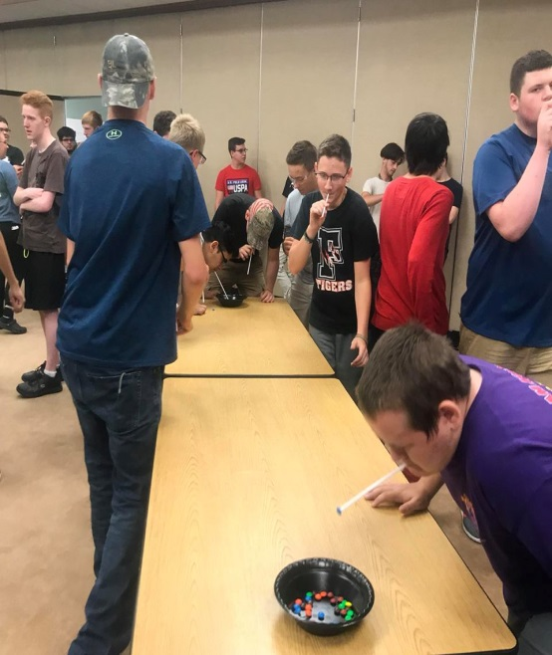

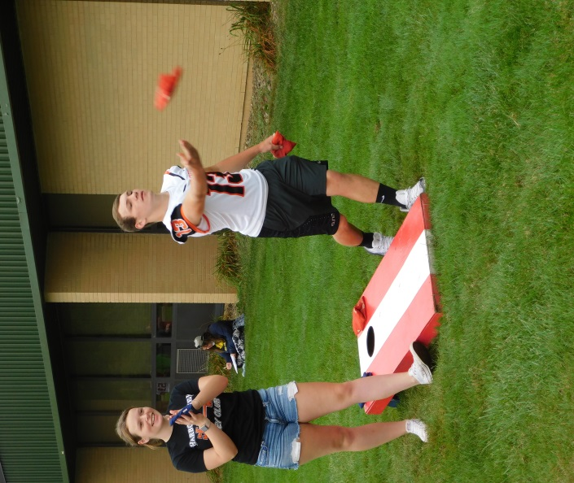` 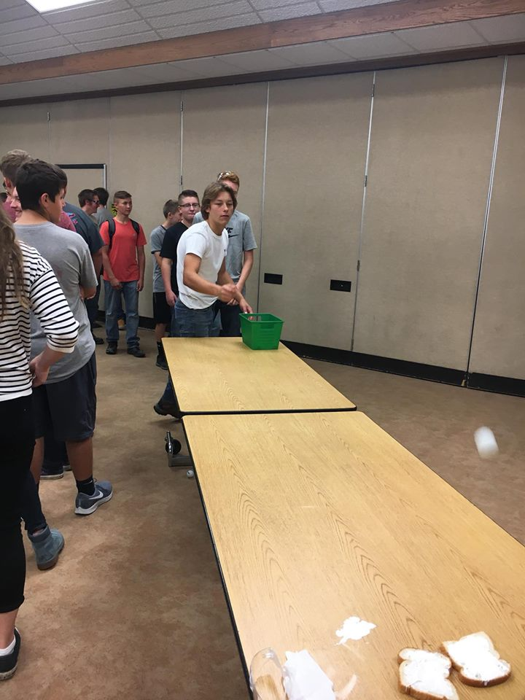
Admissions is responsible for all changes in status, new incoming students, and the scheduling of students in AM/PM sessions. Across 11 districts and 18 programs there is a lot of information to keep in order. I thank our High School Secretary, Pam Lasher, for all of her assistance and support as changes occurred.

We have not redesigned our printed materials in over 5 years. I have been working with Melissa Galbraith to give ECTS admissions materials a new look. We will begin mailing these updated materials to all freshmen in the sending districts by the end of September. All JOC members are included in all mailings to keep you informed of the admissions process. Please watch the mail for these new materials.

I have been in the sending high schools meeting with the Guidance Counselors to review students and set the dates for recruiting. These individual meetings are very helpful in gathering information to assist our current students and understanding the dynamics of each district for recruiting purposes.

Mark Perna, CEO of Tools for Schools gave a presentation on his new concept the Career Tree. Mr. Perna was the consultant that initially developed the ECTS marketing plan several years ago. The marketing team is hoping to move forward at some point with the Career Tree and is investigating the resources needed for implementation.

Over the next several weeks I will begin to update my presentation for the freshmen and attend to the details. As of now there about 50 presentations planned during the month of October. Further details of the presentations will be in the October Admissions report.

September 20-21 is the CTC Guidance Counselors conference at Penn State. This is a wonderful opportunity to network with other Career and Technical Centers across Pennsylvania. The conference always includes updates from PDE and the sharing of best practices. I appreciate the opportunity to attend.

