Project Transfer Agreement

This is a Project Transfer Agreement (“Agreement”), dated as of _______________, 2019, between Erie County Vocational-Technical School Foundation (“Foundation”) and the Greater Erie Community Action Committee (“GECAC”).

Background
- The Foundation has served as the owner of a project known as Career Street (“Project”) since its inception in February of 2014. In this role the Foundation operated the Project, accepted grants and/or donations made to the Project; entered into the contract with the Project’s Executive Director, with a termination date of June 30, 2019 and completed financial transactions on behalf of the Project.
- GECAC agrees to and accepts the transfer of all assets, contracts and tangible and intellectual property of the Project and plans to integrate the Project with the Erie Together Erie County’s anti-poverty initiative.
- Both the Foundation and GECAC are exempt from federal income tax under Section 501(c)(3) of the Internal Revenue Code (“Code”).
- In furtherance of their tax-exempt purposes, the Foundation wishes to transfer the ownership of the Project to GECAC, and GECAC wishes to accept from the Foundation, the Project, including all assets and liabilities in accordance with this Agreement.

Foundation and GECAC agree as follows:

Transfer of Project

Project Assets
Upon the terms and subject to the conditions of this Agreement, on the Effective Date (as defined in Section 2.1), the Foundation will transfer to GECAC all of the Foundation’s ownership, right, title, and interest in and to the assets listed on Exhibit A (“Project Assets”). The Project Assets include all cash held by the Foundation as restricted assets dedicated exclusively to the Project (“Project Cash”).

Excluded Assets
Notwithstanding Section 1.1, the Foundation is not transferring, and GECAC is not acquiring any of the programs, properties, assets (including cash), goodwill, or rights of the Foundation or any of its affiliates of whatever kind and nature, real or personal, tangible or intangible, which are not Project Assets.

1.3 Project Liabilities
In connection with transfer of the Project Assets, on the Effective Date, GECAC will assume all of the liabilities and obligations related to the Project, including, without limitation, those listed on Exhibit B (“Project Liabilities”).

Effective Date of Transfer

Effective Date - Closing
The transfer and delivery of the Project Assets and assumption of the Project Liabilities will take place on July 1, 2019 (the “Effective Date”).

Cash Transfers and Reconciliation

Remaining Project Cash
Foundation will calculate the Project Cash balance as of the Effective Date (“Remaining Project Cash”).

Initial Cash Transfer after the Effective Date
Within three business days following the Effective Date, the Foundation will transfer to GECAC, by check or wire transfer of immediately available funds, an amount equal to Ninety Percent (90%) of the Remaining Project Cash.

Holdback Cash
The Foundation will retain 10% of the Remaining Project Cash (“Holdback Cash”) for up to fifteen(15) calendar days following the Effective Date (“Holdback Period”). The Foundation may use the Holdback Cash to reflect adjustments following the financial reconciliation process set out in Section 3.4.

Financial Reconciliation
The Foundation will perform an internal financial reconciliation of the Project Assets and Project Liabilities during the Holdback Period. The Foundation and GECAC agree and acknowledge that the Project Assets (including Project Cash) and Project Liabilities will be subject to adjustment for accounting or administrative error, payment of liabilities related to the Project which remained outstanding as of the Effective Date, or similar reasons. Following the reconciliation, the Foundation will (a) notify GECAC and increase or decrease, as applicable, the Holdback Cash amount by the amount of the adjustment if the Foundation determines that an adjustment is necessary; and (b) transfer to GECAC, by check or wire transfer of immediately available funds, any remaining Holdback Cash. If the Holdback Cash amount is insufficient or unavailable to satisfy the amount due to the Foundation following determination of the adjustment, then GECAC will pay to the Foundation the amount of any shortfall within 10 calendar days after the Foundation notifies GECAC in writing.

Other Fees and Expenses
Except as otherwise provided in this Agreement, the Foundation and GECAC will each pay all of its own fees and expenses incurred in connection with this Agreement. For clarity, GECAC will be responsible for any fees or expenses charged for transferring ownership of trademarks or domain names and any additional intellectual property included in the Project Assets.

4 Representations and Warranties of Foundation
Foundation represents and warrants to GECAC as follows:

4.1 Organization
Foundation is a nonprofit corporation duly organized, validly existing, and in good standing under the laws of Pennsylvania and has all necessary corporate power and authority to own, lease, and operate its properties, assets, and to carry on its business as currently conducted and as contemplated by this Agreement.

4.2 Authority; Binding Nature of Agreement
Foundation has the requisite corporate power and authority to enter into this Agreement and to carry out the transactions contemplated by this Agreement. The execution and delivery of this Agreement has been duly authorized by all requisite corporate action on the part of the Foundation.

4.3 No Conflict
Neither the execution and delivery of this Agreement by Foundation nor the consummation by the Foundation of the transactions contemplated by this Agreement will: (a) result in a violation by the Foundation of any provision of the articles of incorporation or bylaws of the Foundation; (b) result in a violation by the Foundation or entitle the other party to terminate any contract included in the Project Assets; or (c) result in a violation by the Foundation of any law or governmental regulation applicable to the Foundation, except in each case where such violation or termination would not have a material adverse effect on the Project or this Agreement.

4.4 Title to and Condition of Assets
Foundation has good title to or a valid ownership interest in all of the Project Assets, free and clear of liens, except for: (a) liens which do not materially detract from the value, or materially interfere with the present use, of the Project Assets; and (b) liens for taxes not yet due and payable. Foundation provides the Project Assets to GECAC on an “as is” basis and makes no further representation or warranty of any kind, express or implied, relating to the Project Assets, including, without limitation, implied warranties of the condition, quality, merchantability, fitness for any particular purpose, collectability, or enforceability of any of the Project Assets.

4.5 Litigation
As of the date of this Agreement, there is no lawsuit or other legal proceeding relating to the Project or this Agreement pending (or, to the knowledge of Foundation, being overtly threatened in writing) against Foundation before any court of competent jurisdiction or arbitrator.

5 REPRESENTATIONS AND WARRANTIES OF GECAC
GECAC represents and warrants to Foundation as follows:

5.1 Organization
GECAC is a nonprofit corporation duly organized, validly existing, and in good standing under the laws of Pennsylvania and has all necessary corporate power and authority to own, lease, and operate its properties and to carry on its business as currently conducted and proposed to be conducted as contemplated in this Agreement following the Effective Date.

5.2 Authority; Binding Nature of Agreement
GECAC has the requisite corporate power and authority to enter into this Agreement and to carry out the transactions contemplated by this Agreement. The execution and delivery of this Agreement has been duly authorized by all requisite corporate action on the part of GECAC.

5.3 No Conflict
Neither the execution and delivery of this Agreement by GECAC nor the consummation by GECAC of the transactions contemplated by this Agreement will: (a) result in a violation by GECAC of any provision of the articles of incorporation or bylaws of GECAC; (b) result in a violation by GECAC or entitle the other party to terminate any contract to which GECAC is a party; or (c) result in a violation by GECAC of any law or governmental regulation applicable to GECAC, except in each case where such violation or termination would not have a material adverse effect on the Project or this Agreement.

5.4 Insurance
GECAC has obtained, or will obtain, insurance coverage for the Project’s operations and properties that is customary for a business of the type and scope of the Project, which will be effective on the Effective Date.

5.5 Litigation
As of the date of this Agreement, there is no lawsuit or other legal proceeding relating to the Project or this Agreement pending (or, to the knowledge of GECAC, being overtly threatened in writing) against GECAC before any court of competent jurisdiction or arbitrator.

5.6 Independent Investigation
As the Effective Date of this Agreement, GECAC will have conducted its own independent investigation, review, and analysis of the Project, and acknowledges that it has been provide adequate access to the Executive Director, the properties, assets, premises, books and records, and other documents and data of the Project for such purpose. GECAC acknowledges and agrees that: (a) in making its decision to enter this Agreement and to consummate the transactions contemplated hereby, GECAC has relied solely upon its own investigation and the express representations and warranties of the Foundation in Article 4 of this Agreement; and (b) neither GECAC nor any other party has made any representation or warranty as to the Project, the Foundation or this Agreement, except as expressly set forth in this Agreement.

6 COVENANTS
After the Effective Date, the Foundation and GECAC will perform the following covenants:

6.1 Use of Project Assets
GECAC will use, and will ensure that the Project’s Executive Director uses, the Project Assets, including Project Cash, only for Project-related purposes and to further its mission and tax-exempt purposes under Section 501(c)(3) of the Code and other applicable laws. For clarity, GECAC will not use Project Assets to influence legislation in violation of the Code, to participate or intervene in any political campaign on behalf of or in opposition to any candidate for public office, to induce or encourage violations of law or public policy, or to cause any private inurement or improper private benefit to occur.

6.2 Project Branding and Materials
GECAC will ensure that all Project materials and external communications, including, without limitation, any website, letterhead, registration forms, grant proposals, fundraising solicitations, donation acknowledgments, and contracts, do not indicate that the Project is a sponsored project of Foundation. For clarity, GECAC may permit the Project to use and disclose the Project’s historical financial information and donor lists in furtherance of its mission and operations.

6.3 Payments and Correspondence
If Foundation receives amounts that represent revenue of the Project and which are included in the Project Assets, then Foundation will forward such amounts to GECAC for a period of six (6) months from the Effective Date. Foundation will also forward to GECAC any correspondence or other communications, including, without limitation, any written or email inquiries about the Project or correspondence relating to accounts payable or other items included in the Project Liabilities.

6.4 Confidentiality
Except as may be required by law, neither GECAC nor Foundation will use or disclose to any third party confidential or proprietary information provided by the other, including, without limitation, trade secrets and proprietary information, Project plans and strategies, technical data and research (“Confidential Information”), for any purpose other than carrying out its obligations under this Agreement, without first having obtained the prior written consent of the disclosing party. Confidential Information does not include information that is generally available to the public, information already known by the receiving party before entering into this Agreement, or information the receiving party independently develops.

6.5 Public Disclosure
Except as may be required by law: (a) Foundation and GECAC will consult with each other before issuing any press release; and (b) neither Foundation nor GECAC will issue any such press release or make any such public statement or disclosure without the prior approval of the other.

6.6 Books and Records
Foundation may retain an archival copy of any books and records included in the Project Assets and will keep any Confidential Information included in those books and records in accordance with Section 6.4.

6.7 Further Assurances
Each of Foundation and GECAC will, at the request of and without cost or expense to the other, execute and deliver such agreements and take such other actions as may reasonably be requested in order to more effectively consummate the transfer of the Project Assets, assumption of the Project Liabilities, and the other transactions contemplated by this Agreement. Such agreements may include, without limitation, documents assigning and recording with the United States Patent and Trademark Office and any other appropriate agencies registered patients, trademarks, and other intellectual property rights included in the Project Assets.

7 INDEMNIFICATION

7.1 Survival of Representations and Warranties
All representations and warranties of Foundation and GECAC contained in this Agreement will terminate and expire on, and will cease to have any further force or effect following, the twelve (12)-month anniversary of the Effective Date.

7.2 Indemnification by Foundation
From and after the Effective Date, Foundation will defend, indemnify, and hold GECAC, its directors, officers, employees, agents, and assigns harmless against any liabilities, losses, damages, and expenses (collectively, “Losses”) resulting from any material inaccuracy in the representations and warranties of Foundation set out in Section 4.

7.3 Indemnification by GECAC
From and after the Effective Date, GECAC will defend, indemnify, and hold Foundation and its affiliates, directors, officers, employees, agents, and assigns harmless against any Losses resulting from: (a) any material inaccuracy in the representations and warranties of GECAC set out in Section 5; (b) the Project Liabilities; or (c) operation of the Project, including any act or omission of GECAC relating to the Project, after the Effective Date.
8 MEDIATION

Any controversy or claim arising out of or relating to this contract, or the breach thereof, shall be settled by arbitration administered by the American Arbitration Association in accordance with its Arbitration Rules, and judgment on the award rendered by the arbitrator(s) may be entered in any court having jurisdiction thereof.

9 GENERAL PROVISIONS

9.1 Entire Agreement
This Agreement, together with its exhibits, expresses Foundation’s and GECAC’s final, complete, and exclusive agreement, and supersedes any and all prior or contemporaneous written and oral agreements, arrangements, negotiations, communications, course of dealing, or understanding between Foundation and GECAC relating to its subject matter.

9.2 Amendment
This Agreement may be amended only as stated and by a writing signed by both Foundation and GECAC which recites that it is an amendment to this Agreement.

9.3 Severability
If any provision of this Agreement is held illegal, invalid, or unenforceable, all other provisions of this Agreement will nevertheless be effective, and the illegal, invalid, or unenforceable provision will be considered modified such that it is valid to the maximum extent permitted by law.

9.4 Waiver
Any waiver of the provisions of this Agreement must be in writing and signed by the party granting the waiver. Waiver of any breach or provision of this Agreement will not be considered a waiver of any later breach or of the right to enforce any provision of this Agreement.

9.5 Assignment
Neither party may, directly or indirectly, assign its rights or delegate its duties under this Agreement to anyone else without the prior written consent of the other party.

9.6 Third-Party Beneficiaries
Except as specifically provided in Sections 7.2 and 7.3, this Agreement is for the exclusive benefit of Foundation and GECAC, and not for the benefit of any third party including, without limitation, any of the Project contractors or any affiliate, donor, vendor, or client of Foundation or GECAC.

9.7 Notices
Notices, approvals, and consents under this Agreement must be in writing and delivered to Foundation and GECAC by mail, courier, fax, or email to the contact persons identified on the signature page.

9.8 Governing Law
This Agreement is governed by Pennsylvania law.

*******************
This Agreement was signed by the parties as of the date stated in its first paragraph:
Erie County Vocational-Technical School Foundation |  | Greater Erie Community Action Committee
By:_________________________________  Name: James Bucksbee  Title: President |  | By:_________________________________  Name: Danny Jones  Title: Chief Executive Officer

Foundation’s contact person |  | GECAC’s contact person
Name: | Terri Birchard | Name: | Georgia L. Del Freo
Title: | Business Manager | Title: | Vice President/ Operations
Email: | tbirchard@ects.org | Email: | gdelfreo@gecac.org
Telephone: | 814.464.8662 | Telephone: | 814.870.5402

Exhibits
Exhibit A: Project Assets
Exhibit B: Project Liabilities
Exhibit C: Website hosting agreement
Exhibit D: Grant agreement
Exhibit E: Epic Web Studios Statement

Exhibit A

Project Assets

Financial
- Project Cash- PNC Account: #60-0937-8891 in the approximate amount of $32,000
- Any grants receivable dedicated exclusively to the Project
- Any accounts receivable exclusive to Project and credit balances, advances, and deposits received or attributed exclusively to the Project
- Pre-paid asset Epic Web Studios, $110 website maintenance July and August 2019 payments Exhibit E

Tangible property and records
- Any printer or software (including the related licensing and support agreements for the use of such software) associated with the Project.
- Program and financial records, donor list, Project correspondence, and other documents, including email and written documents relating exclusively to the Project
- Newsletters, brochures, mailing lists, marketing materials, fundraising materials, stationary, client files, Newspapers in Education articles, coloring books and other written or printed materials used exclusively for the Project

Intellectual property
- The Project’s copyrights, trademarks, and logos:
- The Project’s website and URL:
  - www.careerstreeterie.org
  - www.careerstreet.org
  - www.careerstreeterie.com
  - www.summerjamerie.com
- The Project’s social media accounts, including the following:
  - Facebook: https://www.facebook.com/CareerStreetErie/
  - Twitter: https://www.Twitter.com/@CareerStreet

Contracts
- Website hosting agreement, dated February 14, 2018, between Foundation and Fuselab Creative, attached hereto as Exhibit C
- Grant agreement, dated November 27, 2018, between Foundation and Erie Women’s Fund, attached hereto as Exhibit D

Exhibit B

Project Liabilities
- All obligations under all contracts included in the Project Assets, including the Fuselab Creative Agreement, attached hereto as Exhibit C
- Any account payables related to the Project

- Any obligations under the Erie Women’s Fund Grant Agreement, attached hereto as Exhibit D

- All fees owed to Epic Web Studios for website hosting
- Career Street 1.0 careerstreeterie.org Network Solutions $39/year Domain Registration
- Career Street 1.0 careerstreeterie.com Network Solutions $39/year Domain Registration
- Career Street 2.0 careerstreet.org GoDaddy $22/year Domain Registration

Exhibit C
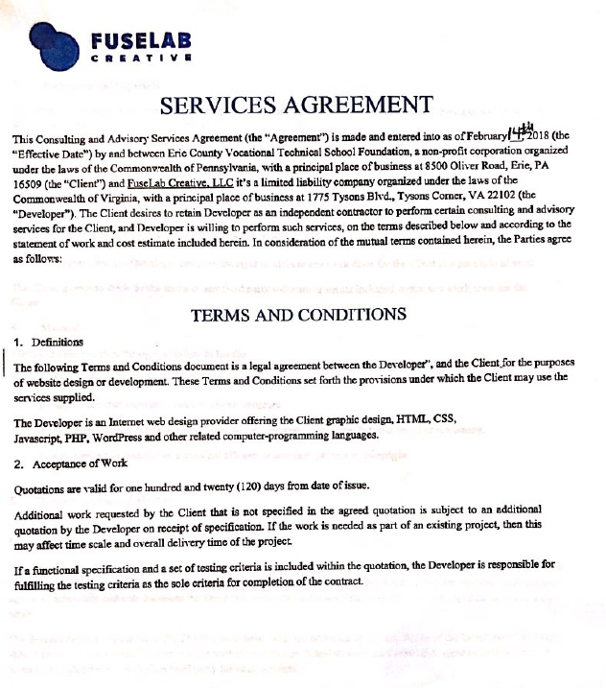
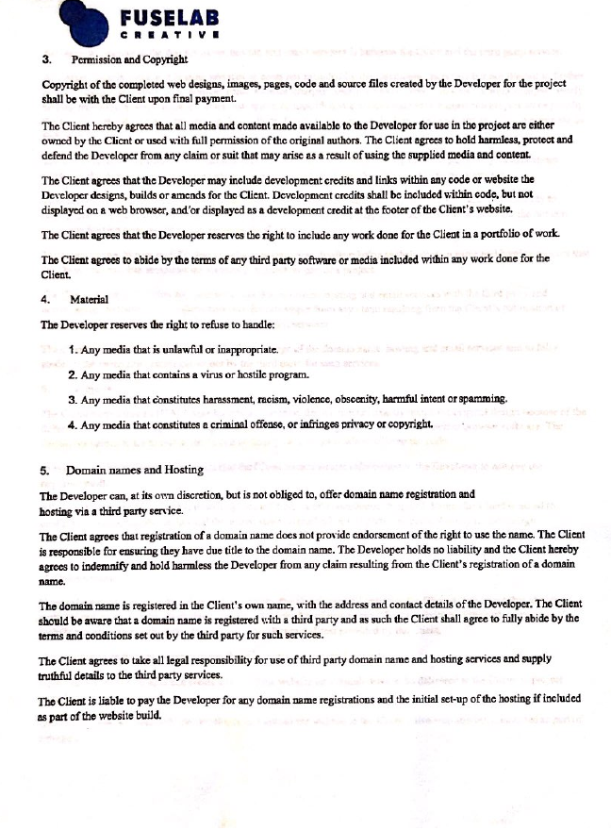
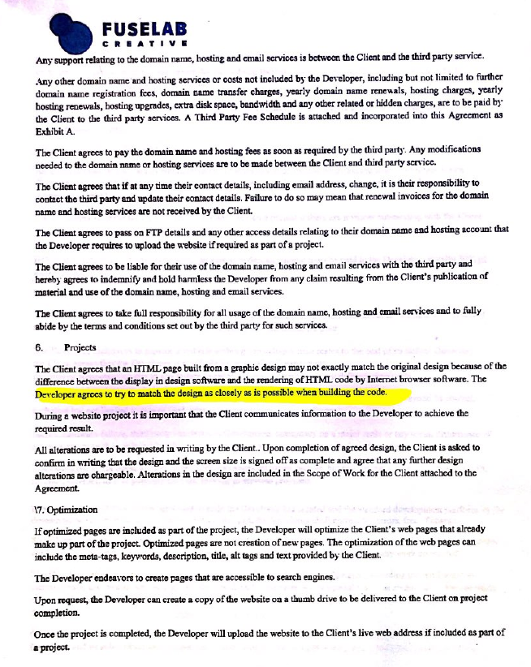
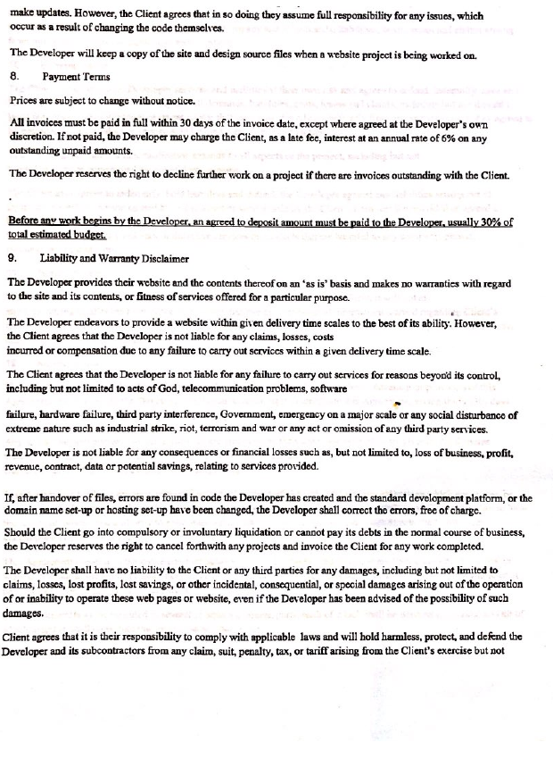
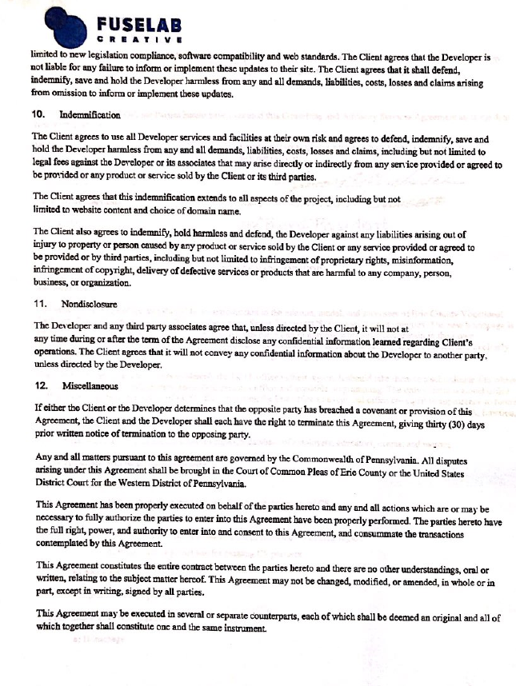
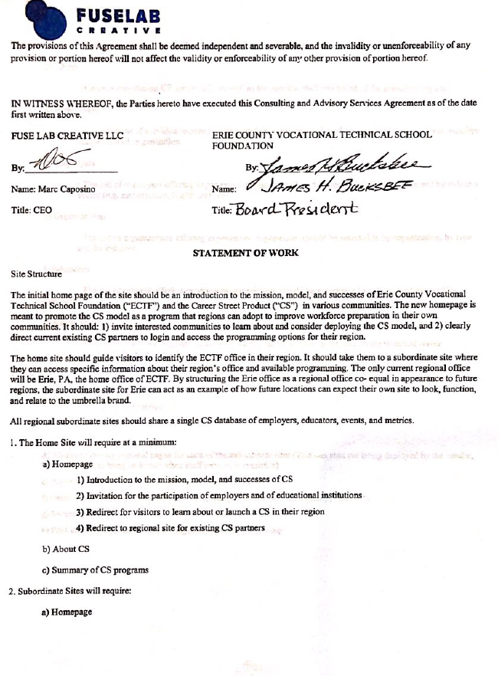
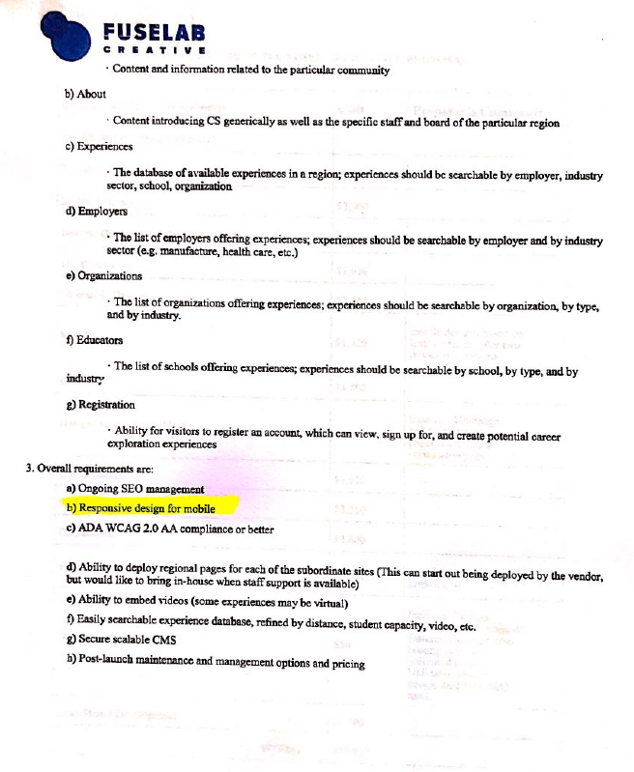
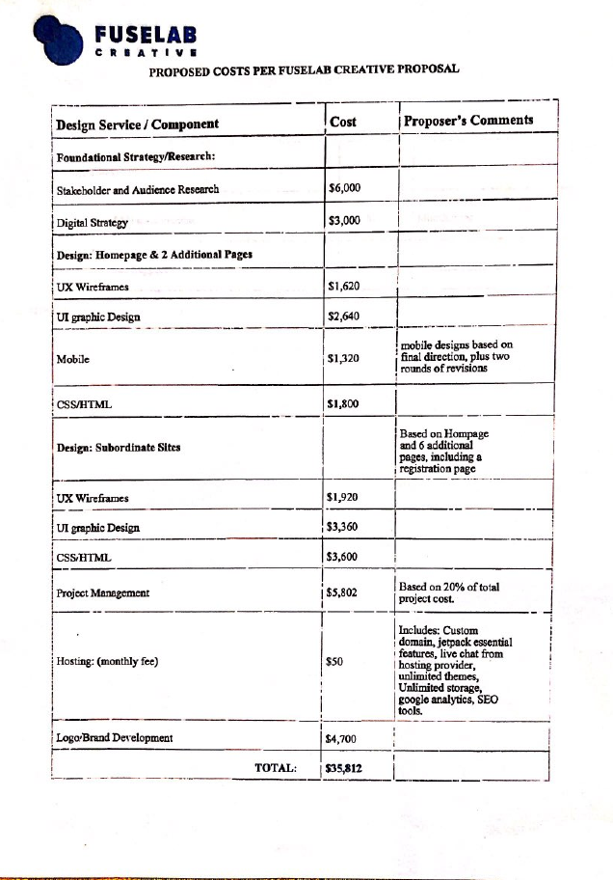
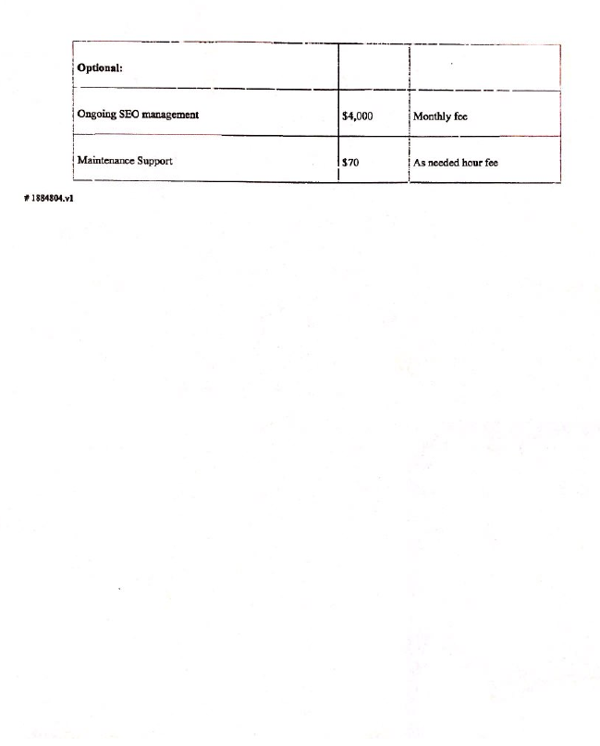

Exhibit D
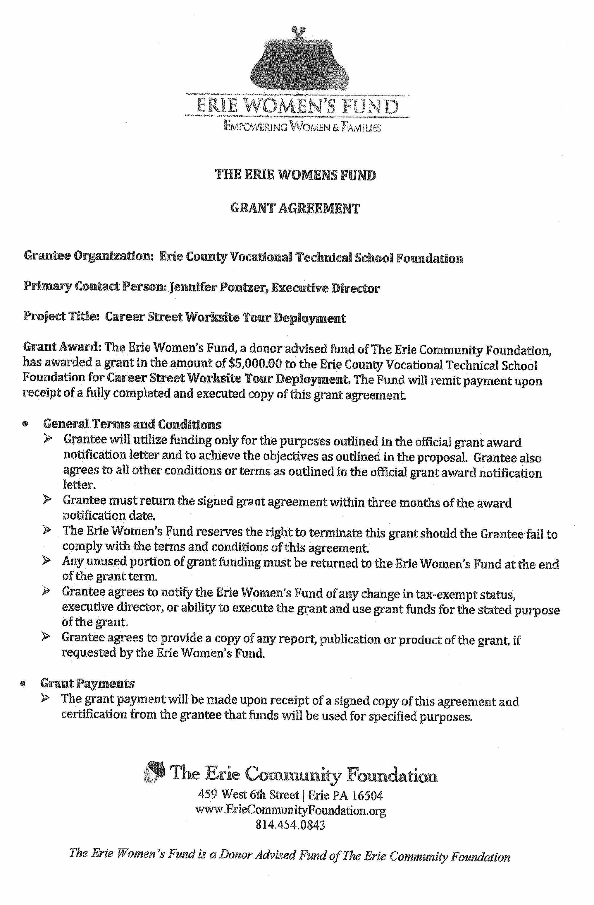
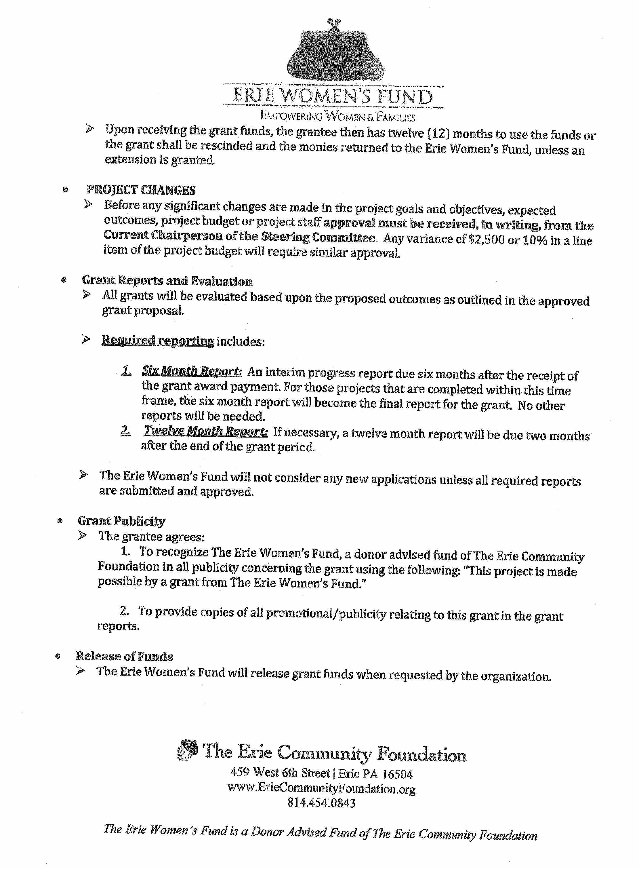
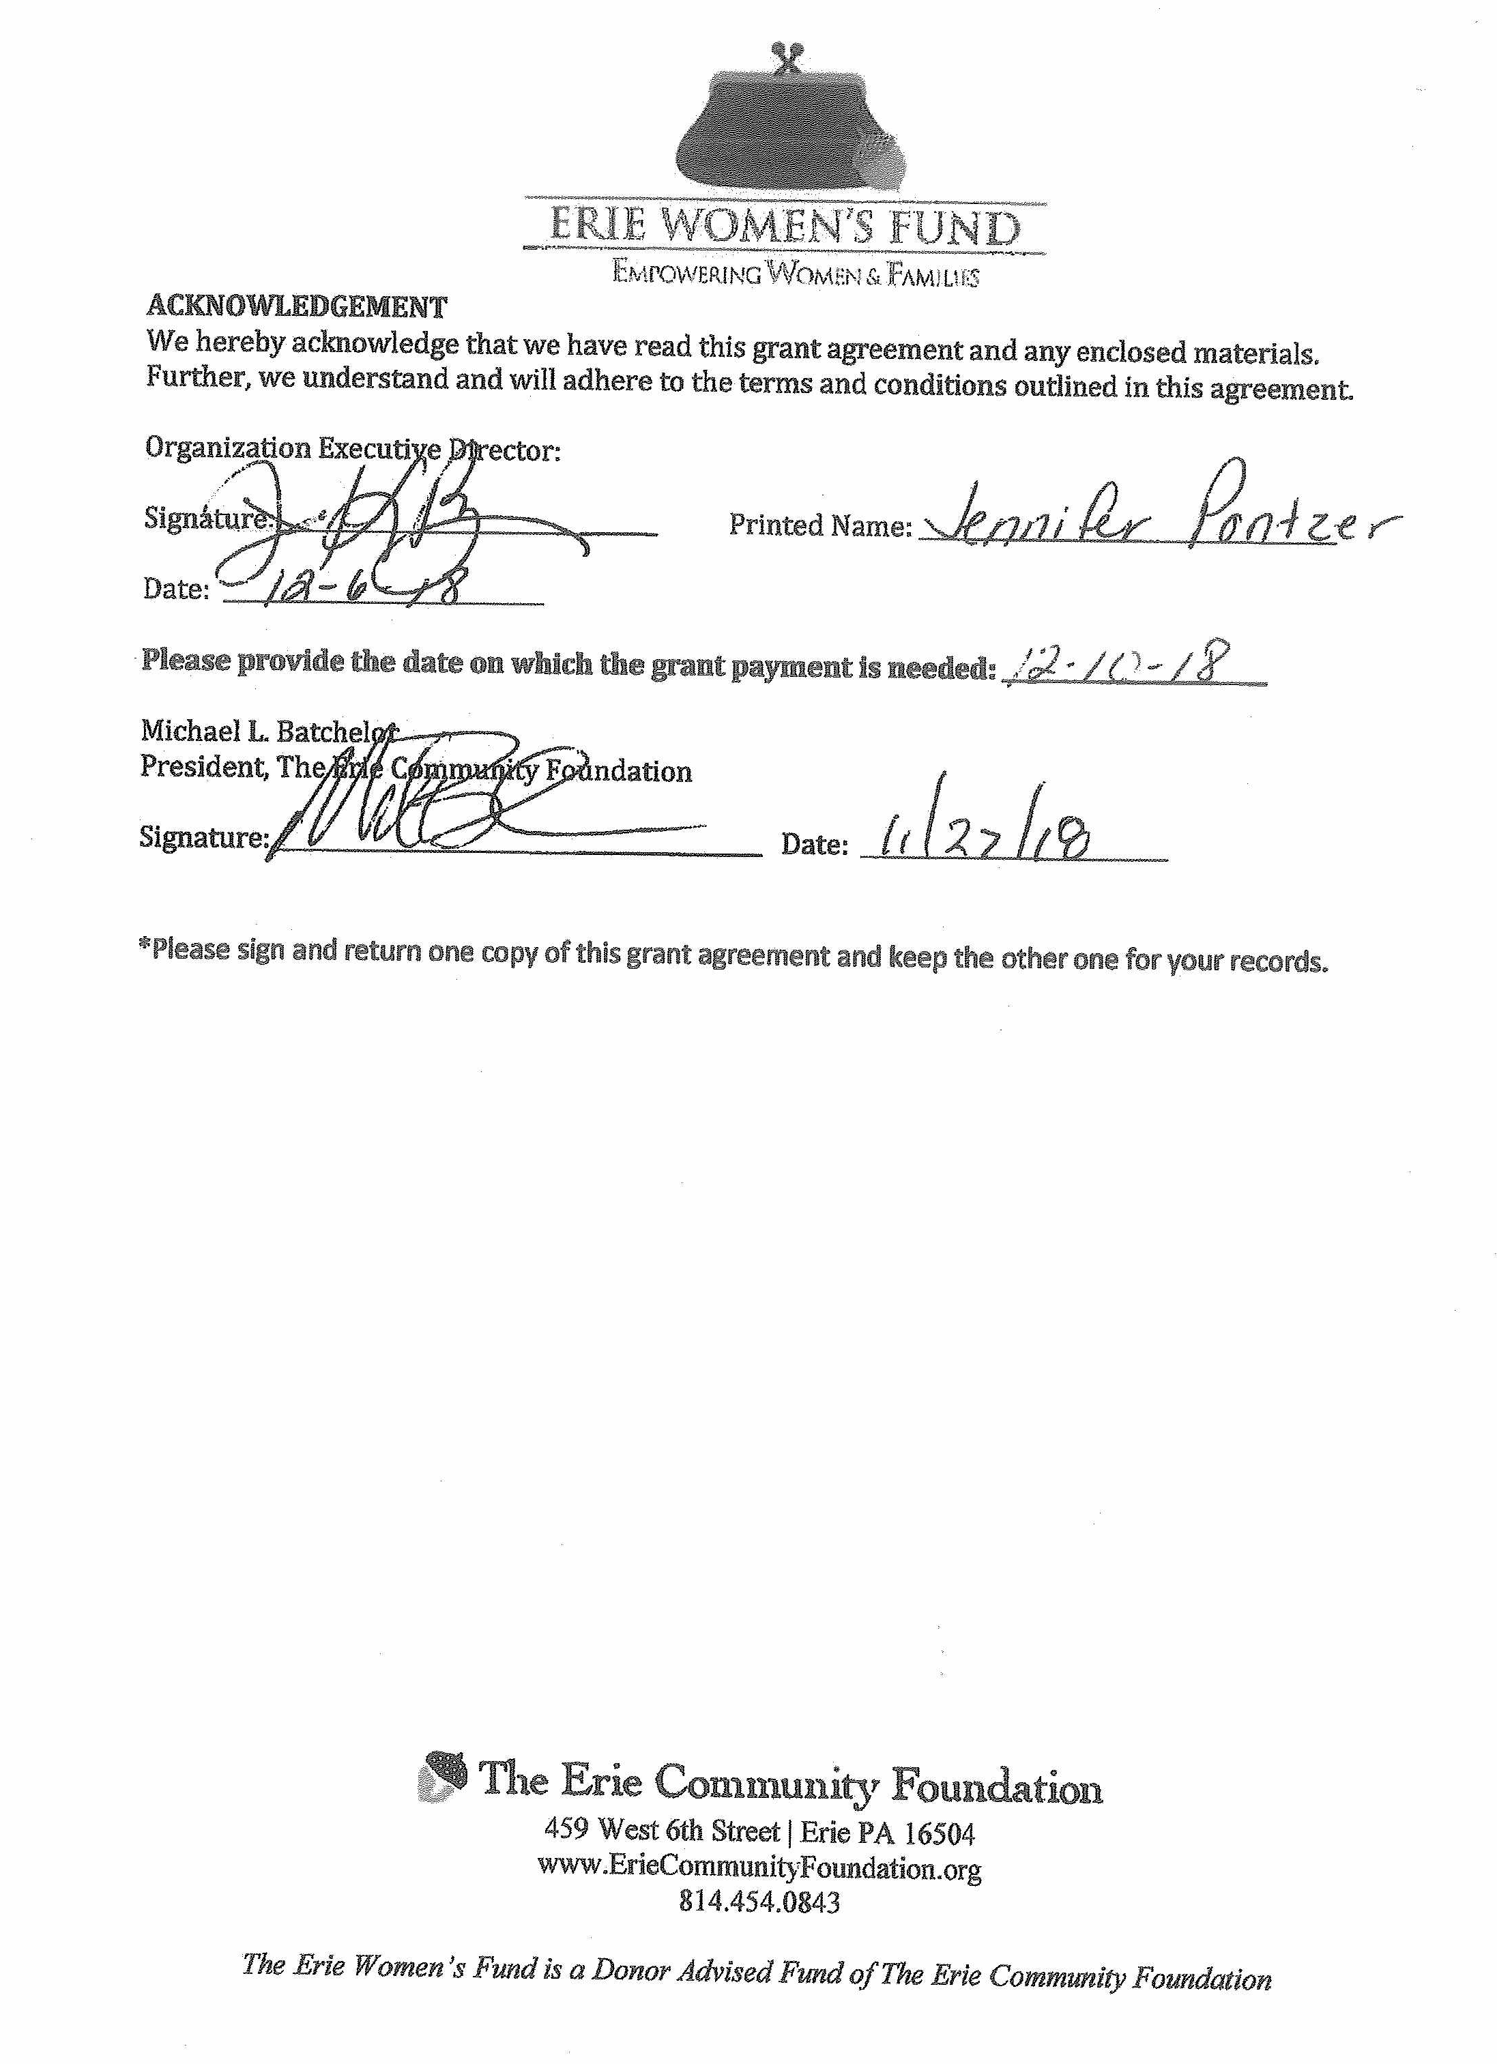

Exhibit E
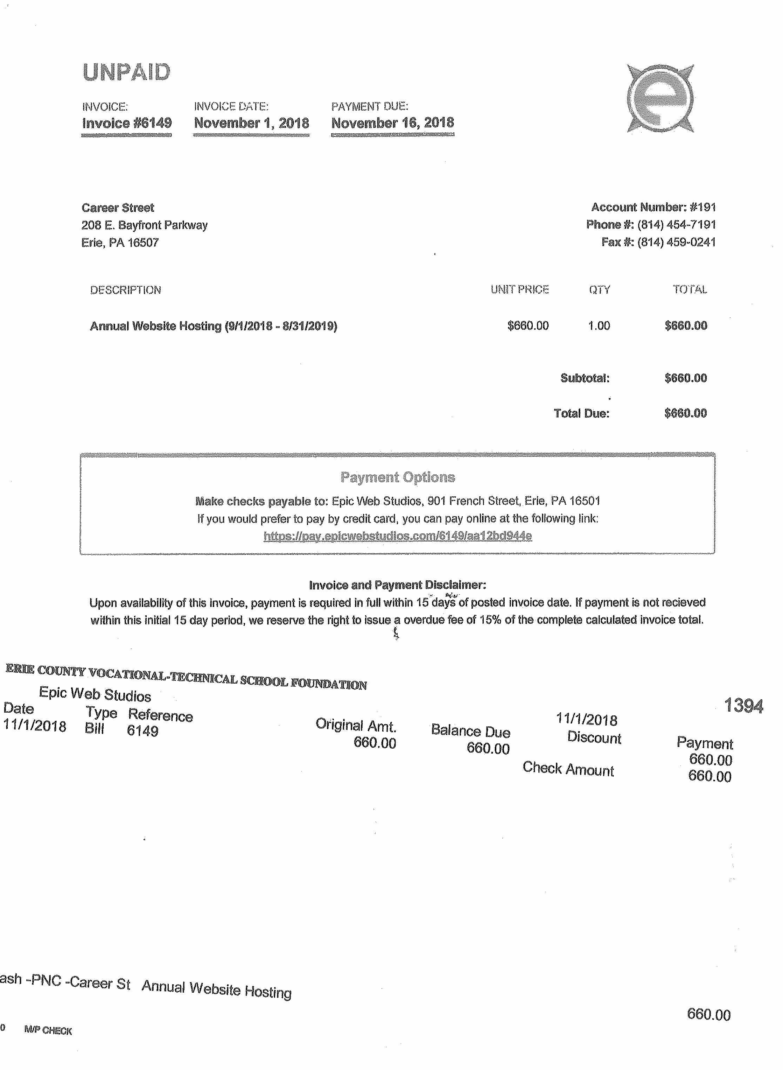
# 2057964.v1

