Career Street Erie  8500 Oliver Road  Erie, PA 16509 | 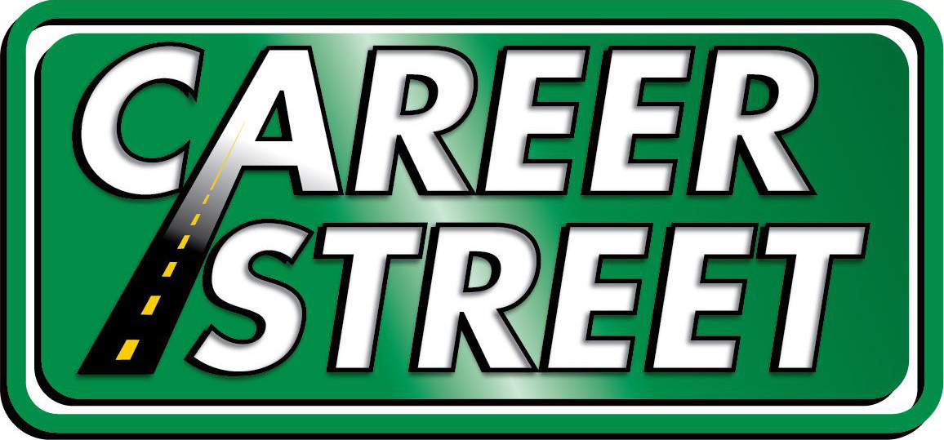
  - Career Street Erie 2018-2019 sponsorship of Erie Times-News in Education

“Invest in Your Future” Contract: 2018-2019
Date | Sponsorship for: | Sponsor of:
May 23, 2019 | Career Street Erie  8500 Oliver Road  Erie, PA 16509 | Erie Times-News in Education  205 West 12th Street  Erie, PA 16534

This contract sets forth the sponsorship terms for Career Street Erie, which will become a sponsor of Erie Times-News in Education's “Invest in Your Future” – a student program page published in the Erie Times-News – promoting career exploration and workforce readiness. Once signed, this agreement shall be considered binding on both: Erie Times-News in Education and Career Street.

Period of Sponsorship

The sponsorship shall commence on September 5, 2018 and shall continue through June 5, 2019.

Description of Partnership

The Erie Times-News will feature Career Street activities and stakeholders on the Wednesday, Erie Times-News in Education Financial Literacy page for 38 weeks during the school year. Partnership also includes full participation in Erie Times-News in Education financial literacy workshops and content on the Wednesday page.
This agreement also allows Career Street to provide no less than 18 and no more than 38 supplemental articles to be featured on the “Invest in Your Future” page. These articles should be no more than 500 words and pertain to career choices, financial literacy, entrepreneurship or college preparation. Articles will be submitted to the Erie Times-News on Friday by noon prior to the publication date.
The Career Street logo will be featured on each of the 38 Wednesday editions of the Erie Times-News. The logo and a destination URL will also be featured on the homepage of NIE.GoErie.com.

Payment Terms
Career Street Erie agrees to pay the sum of $10,000 at two payments of $5,000. Dates to be mutually agreed upon.

*Note: Career Street Erie may opt to pay $10,000 at one time.

Sponsorship Scope
Cost of full-year option includes logo and content in Erie Times-News Wednesday edition.

Cost of Erie Times-News access is 19 cents per license. Alliance for Audited Media, which oversees the ETN circulation audit, allows educational copies to be sold for 19 cents, allowing the sponsor’s dollar to reach more students. $10,000 allows approximately 52,000 licenses during the 38 weeks – or approximately 1,460 students/teachers per week.

Outreach
4,500 students each week in Erie Times-News eEdition and over 26,000 print (home-delivery and single-copy) editions.

“Invest in Your Future” Schedule

September 5, 2018 | November 28, 2018 | February 20, 2019 | May 8, 2019
September 12, 2018 | December 5, 2018 | February 27, 2019 | May 15, 2019
September 19, 2018 | December 12, 2018 | March 6, 2019 | May 22, 2019
September 26, 2018 | December 19, 2018 | March 13, 2019 | May 29, 2019
October 3, 2018 | January 2, 2019 | March 20, 2019 | June 5, 2019
October 10, 2018 | January 9, 2019 | March 27, 2019
October 17, 2018 | January 16, 2019 | April 3, 2019
October 24, 2018 | January 23, 2019 | April 10, 2019
October 31, 2018 | January 30, 2019 | April 17, 2019
November 7, 2018 | February 6, 2019 | April 24, 2019
November 14, 2018 | February 13, 2019 | May 1, 2019

Upon completion of this sponsorship, Career Street Erie will have the option to renew this agreement for an additional school year at the $10,000 level for those resources identified.

Content in this contract is subject to change, upon agreement by both Erie Times-News in Education and Career Street Erie.
Career Street Erie
_______________________________________________________ _______________________________

James Bucksbee, Foundation President Date

Erie Times-News in Education

_______________________________________________________ _______________________________

Amanda Farrell, Audience and Consumer Marketing Manager Date



