Erie County Technical School
Admission Coordinator Board Report
October 2016

In November 1276 freshmen from all 11 sending school districts visited ECTS. All of the students had a name badge listing the 3 programs they were visiting (chosen in October at ECTS presentations). Student spent about a half hour in each of the 3 programs participating in an activity related to the program as well as learning about the tolerances and expectations to find success. The photos below show some of the activities students experienced during the ECTS Showcase.

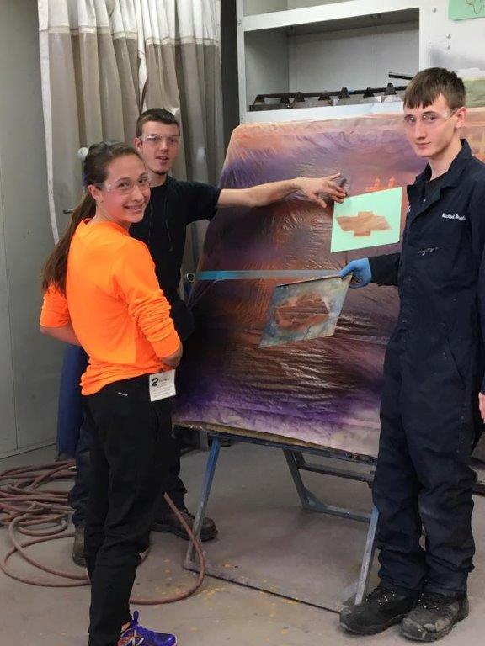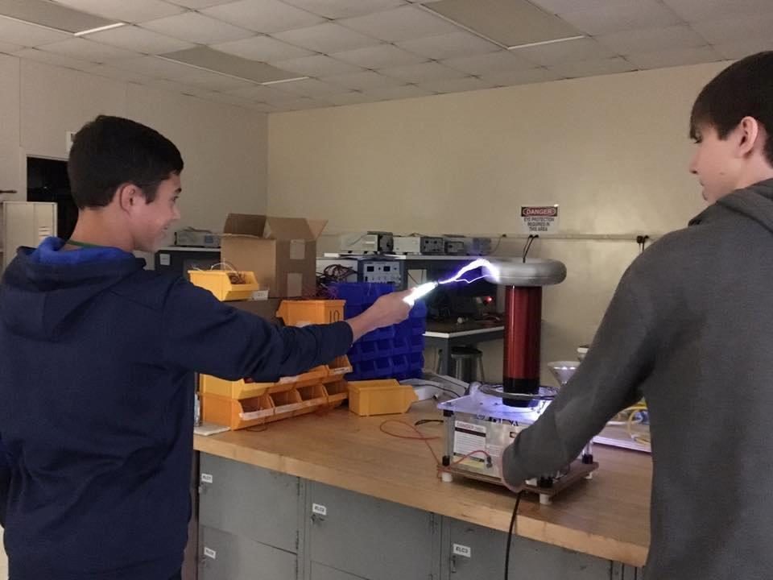

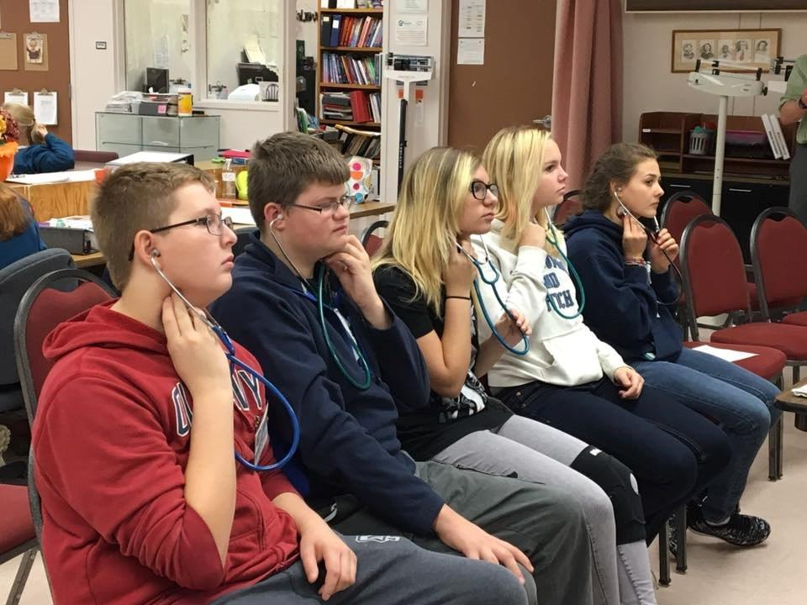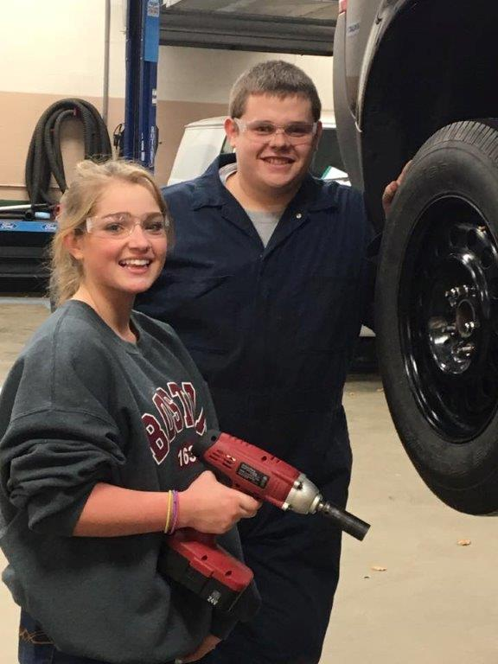

The ECTS staff did an outstanding job of planning and implementing activities, preparing current students and their classroom environment, as well as assisting in moving the freshmen throughout the building.

172 families attend the New Student Open House on November 17. This is our record high! We appreciate the sending high school Counselors that assisted us in promoting the event by displaying posters and making announcements days prior. All JOC members should have received the ECTS Open House postcards that were send to the 9th graders and their families in each sending school as well as a Priority Enrollment reminder date card. The Priority Enrollment date is December 16. This is the day applications are due to the Guidance office in each sending school.

In December students interested in applying may visit ECTS for a half -day session. This gives students a true feel for a typical day at ECTS. We are enjoying the many students visiting each day. Again, ECTS teachers are doing a wonderful job in welcoming our guests and ensuring they have a good experience.

Applications have begun to arrive. The Counselors of the sending schools tell me there is a lot of buzz among the freshmen about ECTS. Applications are not due to ECTS until after the first semester ends. The Counselors have quite a bit of work to do on their end to complete the process before sending them to me. Their many efforts in the process help us to work collaboratively to ensure students are making good choices and will find success at ECTS.

I was invited to represent ECTS at Wattsburg’s Choose Seneca evening and will be attending the scheduling night at Harbor Creek High School. I appreciate the opportunity to be a part of these types of events as well as open houses. It gives me the chance to speak with parents and show all parents and students in attendance that ECTS is another opportunity for students within their school district.

Erie Together had their community forum in November at the Bayfront Convention Center. I am a part of the Aligning Careers to Education Action Team. The community forum provided reports from all action teams. Erie Together is doing great things to help our community and I am thankful to have the opportunity to participate in this endeavor.

The 2nd quarter Guidance Counselor meeting will take place at ECTS on December 16. Some of the topics on the agenda include, transfer student process, withdraw process, scheduling of honors and AP classes to ensure ECTS students have the opportunity to take them, and review of current students grades and attendance. These quarterly meetings also help to ensure the success of ECTS students.

I wish you and your family a Very Merry Holiday Season and a Happy, Healthy New Year!

