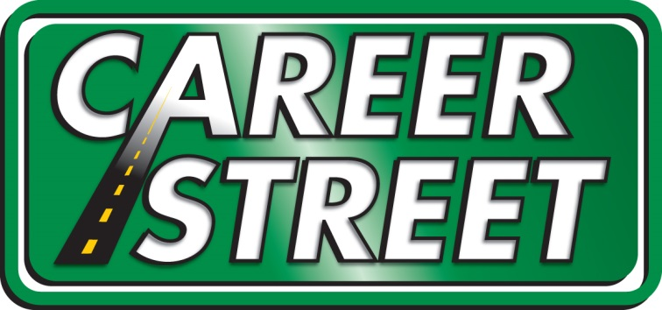®

Career Street ECTS Foundation Board Meeting Report
March 24, 2016

- Data report
  - Number of Businesses (104 last month) 113, 9% growth
  - Number of Experiences (122 last month) 135, 9% growth
  - Number of Matches (153 last month) 237, 60% growth
  - Number of Students (9,377 last month) 11,105, 80% growth

**Special Note: Last month’s report included the number of experiences by school district. It is important to note that there are more career exploration experiences occurring in some of the districts than reflected on that report. Some school districts have advanced career exploration curriculum and this is not yet integrated with Career Street. We are working on this integration, however that data does not honestly represent the career exploration and education occurring in those schools. To be specific, at this time, Fort Le Boeuff and Iroquois School Districts. I continue to work with all school district Career Street Liaisons to have complete career experience data.

- How to deepen school usage
  - Continued outreach
  - Contact with employers to offer more experiences
  - Potential for video tours on website (virtual tours) as experience
- How to deepen Business Usage
  - Meeting with Erie Together Career Street Task Force regarding assistance in the area
    - Identifying need for more boots on the ground/how to help
- Speaking Engagements
  - NC3T (National Center for College and Career Transition), PiN (Pathways Innovation Network) community supported effort to workforce development
- Other projects
  - Educator in the Workplace
    - Still in planning stages, framing stages
    - Encouraged during Community Tour
    - Encouraged during PA PiN Mtg
  - Trolley Tour for 7th Grade History Teachers
    - Itinerary Attached
    - Survey Results attached (15 out of 21 responses)

- Sustainability
  - Fundraising efforts have been targeted at a 1 on 1, this has been effective
  - Soft goal of raising $50,000 in 2016
    - 30% goal attained

New Testimony from Iroquois School District:
“We have used career street for several of our field trips this year including the Career Fair at TREC, Manufacturing Day, and TechFEST. All have been wonderful events that helped enhance our students understanding of careers and college preparation. It is imperative that our students are begin exposed to a variety of career fields and activities that help them gain a better understanding of their interests and potential career options. All of the field trips were engaging, relative to our students, and met their target objectives. I will continue to use Career Street in providing our students with educational opportunities that can expand their career knowledge and preparation.
Sarah Skelton, Gifted Coordinator
Iroquois School District

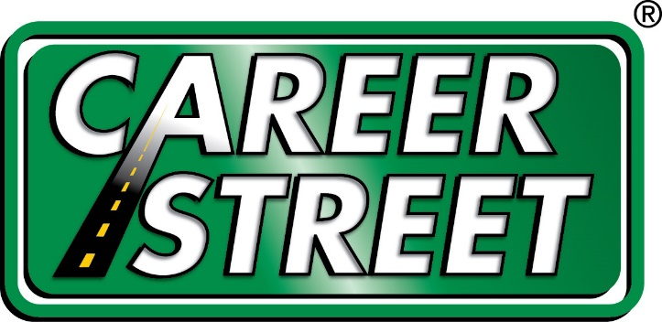
Career Street Community Tour Itinerary
7:45 Assemble at Park N Ride on 12th & Lincoln: Coffee & bagels provided
8:00 Depart
8:15 Erie Insurance Tour(we will be touring the Technical Learning Center first – this is the “old Achievement Center” on the corner of W 6th and French and have been instructed to use the 7th Street entrance. You can stay parked in that lot until it’s time to board) – employs 2,300 locally
9:30 Board shuttle
9:45 Erie Water Works Tour, employs 110
10:45 Board shuttle
11:15 Port Erie Plastics Tour, employs 400
12:15 Board Shuttle
Bag lunch and water provided
12:45- 1:45 Curtze Food Services Tour, employs 350
As far as parking for the shuttle:
- Bus driver can drop everyone off at the front door
- Shuttle can exit the parking lot and turn west to re-enter the entrance
- The shuttle can then proceed straight to the back of our facility to park in the rear
1:45 Board Shuttle to return to Park N Ride
**My cell phone number is 814.572.0419 - Jennifer Pontzer
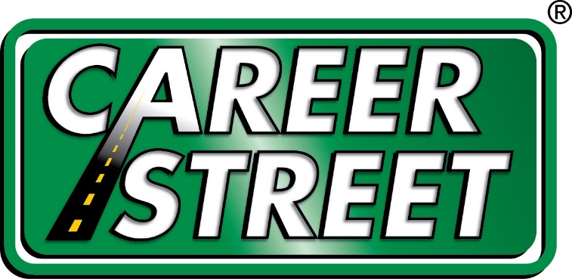

Community Tour Survey Results:

- Did you enjoy the tour?
  - 100% yes
- Did you learn about a variety of career exploration experiences?
  - 100% yes
- Are you able to take what you learned on the tour and use it in the classroom?
  - 100% yes
- Were you familiar with Career Street prior to the tour?
  - 73.3% yes (11)
  - 26.7% no (4)
- Will you be using Career Street for career exploration experiences from this point forward?
  - 100% yes
- Would you recommend a Career Street Community Tour to a friend?
  - 100% yes
- Would you recommend Career Street to peers?
  - 100% yes

Community Tour Survey Comments:

Is it possible for Career Street to organize "field trip itineraries", similar to what we followed yesterday? Schools can sign up for a set collection of career stops to fill a day. Rather than having to coordinate individual sites to fill a day, a set itinerary could be selected?

I think the tour was fantastic! I learned a great deal about the needs of our area businesses that I was not aware of. Thank you for organizing the trip. It was extremely worthwhile. I have already spread the word throughout the building and I look forward to working with Career Street.
It was a beneficial experience.
Thank you for the time and hard work you put into the day!
Thank you for a wonderful, interesting experience!
I work with Gifted students, so I am particularly interested in providing direction for the college-bound student and offering insight on degrees required for certain jobs and by companies. Thank you for all your hard work yesterday; it was quite enjoyable.
I had a great time...very well organized program!
It was very organized and I enjoyed the experience. It is definitely something that I am interested in and will share my experience with other educators. I also will have a little talk with some of my students about some of the points I picked up in the presentations

