Supervisors of Instructional Support Services Report
November 2011
Jan Kennerknecht and Pat Holland

National Program Certification
An on-site evaluation was held for the Culinary Arts program on November 4, 2011. Two representatives from the American Culinary Federation were greeted at a reception the evening before which was held at the Hilton Garden Inn. Following a day-long review the following day, an exit interview was held to discuss program strengths, non-compliances and suggestions. Strengths listed included:

- The use of time cards to reflect an industry environment
- The use of industry guest speakers
- Our ‘passionate, approachable instructors’
- The use of computers in the classroom
- The ability of instructors to combine an effective learning environment with a production schedule

After observations, review of the Self-Study binder and student and staff interviews, there were no non-compliances found. The evaluators gave a few suggestions for improvement which will be entered into our ISO Continual Improvement system for follow-through. A decision on re-certification of our program should arrive within 6 weeks. We expect a positive decision.

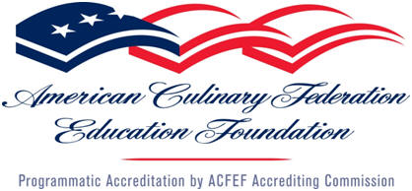 | 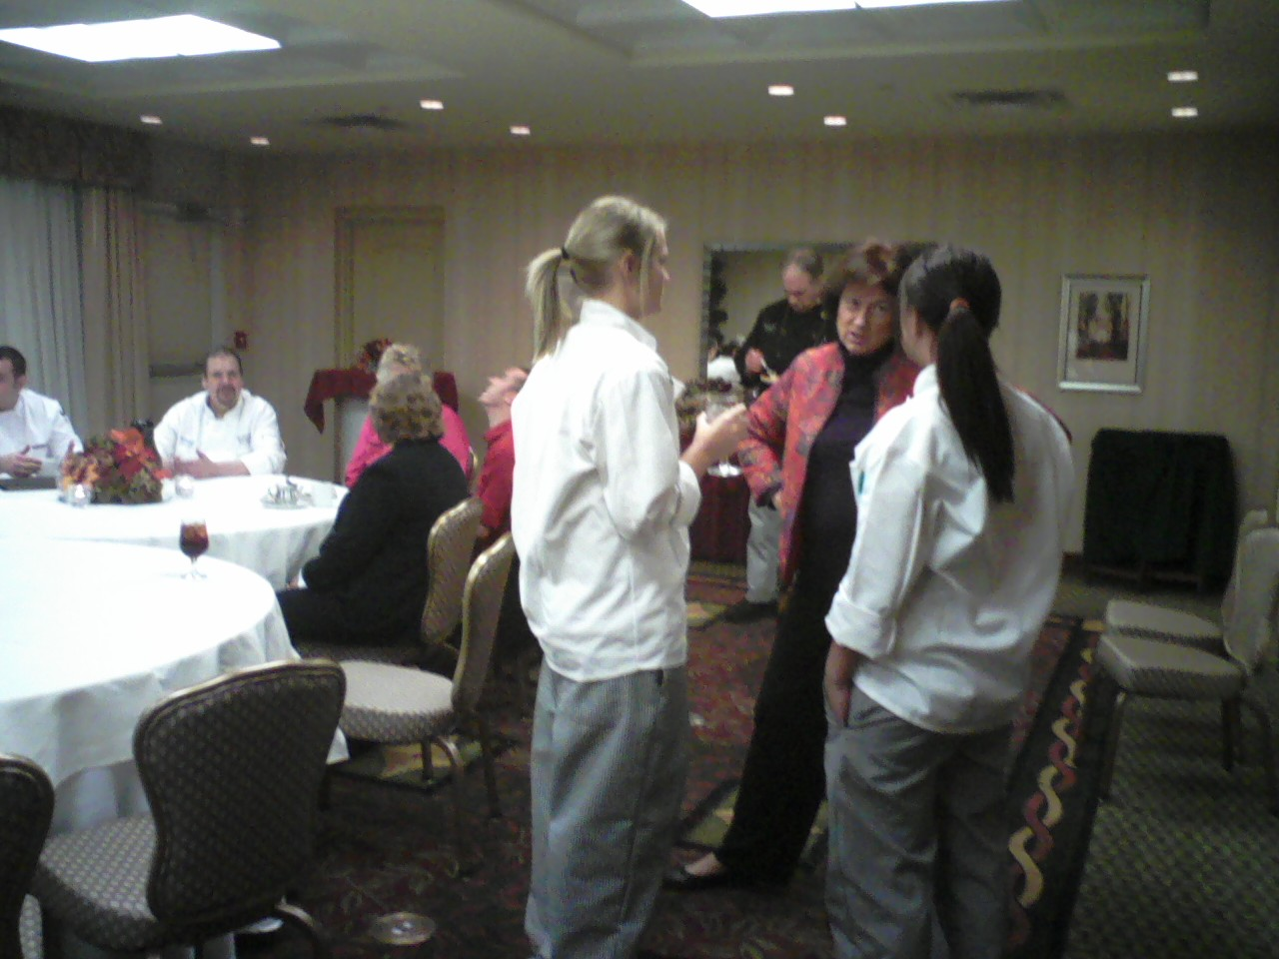

Special Education
First quarter grades for all of our students with special needs have been e-mailed to special education case managers and counselors at all of our sending high schools. Approximately 98% of our students with disabilities earned a passing grade for the first quarter. Jan and Pat have followed up with the instructors, instructional aides and students to develop a plan of assistance for those who did not pass. Senior Transition Staffings were hosted by Jan and Pat with the district transition coordinators, supervisors and agency personnel.

Literacy
With the start of the second quarter, our instructional staff is modeling how students can make connections with what they are reading in their textbooks and what they know and what they have done. The other Literacy Initiative that our instructors are working on is how students can decipher text structure. Here our instructors are reviewing with students the different structure of textbooks by previewing the chapters in their textbooks and how the text is organized. Both of these strategies are building blocks to comprehension and are ways to help our students make better meaning of what they read in their textbooks.

